Software Requirements Specification
The Butler Did It
10/16/2012

Introduction
User Registration and Authentication Subsystem
Game Formation Subsystem
Use Cases
Creating/Starting a Game Use Case Diagram
Navigation Subsystem
Use Cases
Navigation State Diagram
Suggestion Manager Subsystem
Use Cases
Suggestion Manager Flowchart
Accusation Subsystem
Use Cases
Accusation Flowchart
Information Domain

Introduction
From the creators of every childhood game that you loved, comes a new one from The Butler Did It. In a “who done it” thriller that will have players at the edge of their seats comes Clue-less, the step brother to the popular game Clue.
This document will present requirements about the game. We will show from a high-level view a step by step process to go from registering/logging in, to playing and finding the murderer.

User Registration and Authentication Subsystem
Users will self register themselves as Clue-less players. After registration, users authenticate themselves to the system with their username and password.

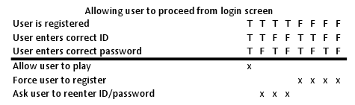

Game Formation Subsystem
Players of the Clue-less system form their own games in the game lounge. Players in the game lounge may join any game that has yet to start. Alternatively, players may create their own game and encourage other players to join.

Use Cases
Name: Player joins game
Actor: Player
Preconditions: Player has logged in successfully, player is not currently participating in a game, and there is a vacant spot in a game that has yet to start.
Postcondition: Player has successfully joined the game and for the host to start it in the pre-game lobby.

Name: Player creates game
Actor: Player
Preconditions: Player has logged in successfully and is not currently participating in a game.
Postcondition: Player has successfully created the game and is now Ms. Scarlet by default.

Name: Game host starts a game
Actor: All Players
Preconditions: Player has created a game, is in the pre-game lobby, and there are at least 2 other participants.
Postcondition: System assigns players a character and game play begins

Creating/Starting a Game Use Case Diagram
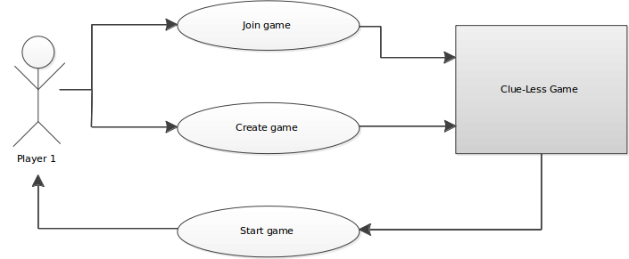

Navigation Subsystem

Use Cases
Name: Player navigates into a Room
Actor: Player
Preconditions: Player’s pawn is in a Hallway
Postcondition: Player’s pawn is moved from a Hallway into an adjacent Room

Name: Player navigates into a Hallway
Actor: All Players
Preconditions: Player’s pawn is in a Room with an adjacent Hallway that is vacant
Postcondition: Player’s pawn is moved from a Room into a vacant adjacent Hallway

Name: Player with no vacant Hallways
Actor: All players
Preconditions: The player’s pawn is in a Room with all adjacent Hallways occupied by other player’s pawns.
Postcondition: Player’s pawn remains in Room.

Name: Player choosing a Passageway in Room
Actor: Player, Room’s with Passageways
Preconditions: Player’s pawn is in a Room with a Passageway.
Postcondition: Player’s pawn is moved to the Room on the far diagonal of the board.

Navigation State Diagram
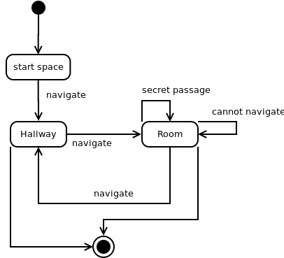

Suggestion Manager Subsystem

Use Cases
Name: Player creates a suggestion
Actor: All Players, Rooms
Preconditions: The Player’s pawn must be in a Room.
Postcondition: The Player chooses one Weapon, and one Suspect in the Room they are in to form the suggestion to the murder

Name: Player disproves a suggestion
Actor: All Players, Clues
Preconditions: A suggestion has not been disproven, and a player holds one of the suggestions Clues.
Postcondition: In a clockwise fashion, the first player with at least one initial Clue that matches the suggesting player’s suggestion must disprove said suggestion by selecting one of the Clues. This Clue is shown to the Suggesting player. All other players only are aware of who disproved the suggestion. The game returns to the suggesting player.

Name: Player is unable to disprove suggestion
Actor: Player’s hand
Preconditions: A potential disproving player doesn't hold a clue that can disprove the suggestion.
Postcondition: The potential disproving player is notified that they do not have a Clue that can disprove the suggestion. They are passed to the next potential disproving player.

Suggestion Manager Flowchart
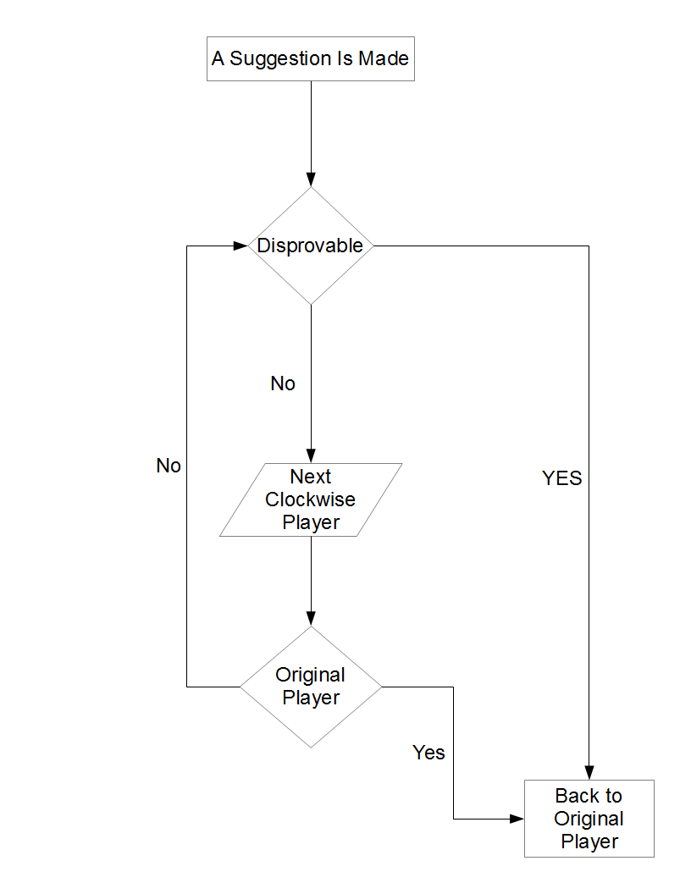

Accusation Subsystem

Use Cases
Name: Player makes correct accusation
Actor: player
Preconditions: Player is in a game and it is his/her turn.
Postcondition: System informs all participants that this player has won the game. The game's status is changed to 'finished' and the system records the winner.

Name: Player makes false accusation
Actor: player
Preconditions: Player is in a game and it is his/her turn
Postcondition: Player is no longer a contender. System informs all participants that this player has lost and play continues with the next contender

Name: One contender remains
Actor: system
Precondition: All participants but one have made false accusations and are therefore no longer candidates.
Postcondition: System informs all participants that the sole remaining candidate won the game. The game's status is changed to 'finished' and the system records the winner

Accusation Flowchart
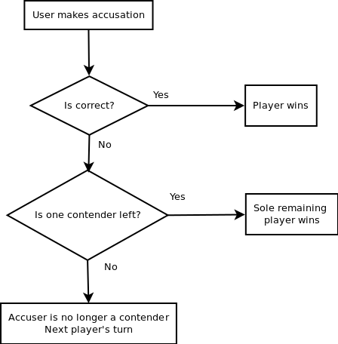

Information Domain
The information domain serves to describe the entities, the values they store, and their relations to each other. This Domain Class Diagram shows shared entities across all the subsystems.

